

F5 SSL VPN

Support Document

Sponsor: Information Security, DCOS

Effective Date: May 1st, 2018

Last Review Date: September 5th, 2018

Report Errors: it_riskmanagement@uth.tmc.edu

Table of Contents

Purpose 1
Responsibility 1
Scope 1
Definitions 1
Installation Procedures 2
Windows 2
Mac 4
Chrome OS 9
Android 14
IOS (iPhone, iPad) 16
Linux 20

Contacts 23
Revision History 23

PURPOSE

To inform various support staff and users how to install and connect to the UTHealth network via a VPN connection.

RESPONSIBILITY

The Desktop Support Team and IT Security are responsible for updating this document.

SCOPE

Any user who needs to connect to UT Health’s network remotely.

DEFINITIONS

Term | Definition
Android | Any device running android mobile operating system
Big IP Edge Client | F5’s SSL-VPN Client
EULA | End User License Agreement
Firefox/Google Chrome/Edge | Internet browsing applications
Mac OS | Operating system for Mac computers
Windows | Microsoft Windows operating system

Windows Client Installation

- Go to: https://utvpn.uth.edu
- Click on the link to download the Windows Client.

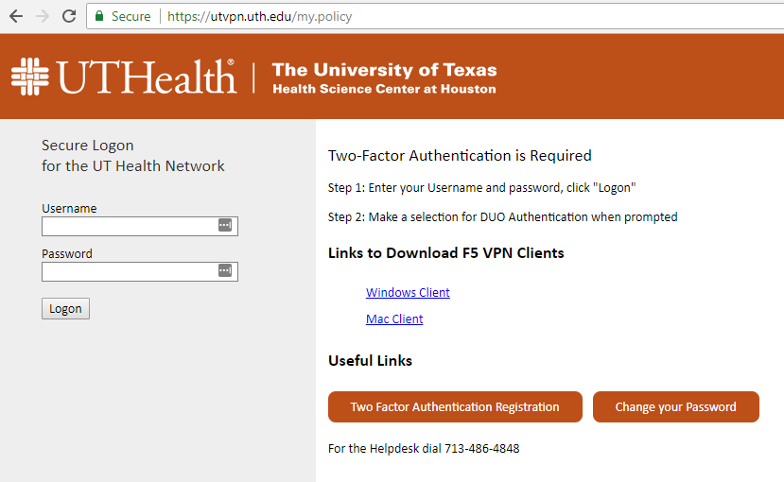

- Run the file that was just downloaded and click install as shown below:

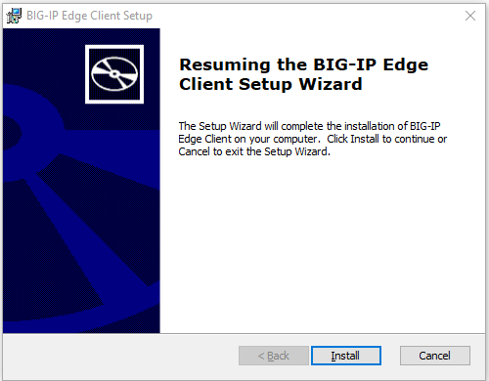
- Click “Next”, accepting all defaults.

- After the VPN client has installed, click on "Start" and look for the "Big-IP Edge Client".

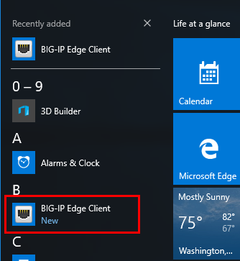

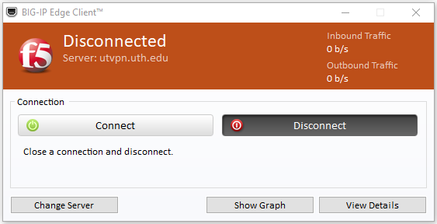
- You are all set. Now click "Connect" and enter your credentials when prompted.

Mac Client Installation

- Go to: https://utvpn.uth.edu

- Click on the link to download the Mac Client.

- For Macs, Do Not install the F5 App from the Apple Store.

- Copy the file "Mac_BIGIPMacEdgeClient13.1.2.zip" file to the Mac desktop.

- Double-click on file to unzip it and it will create a folder on your desktop as shown below:

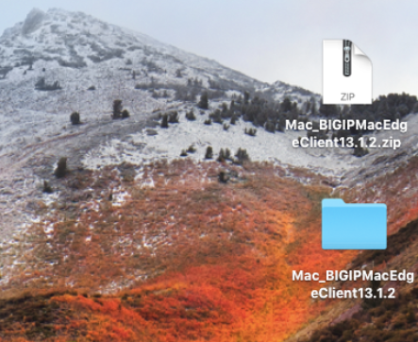

- Open the new folder and double-click on the file "mac_edgesvpn.pkg" as shown below:

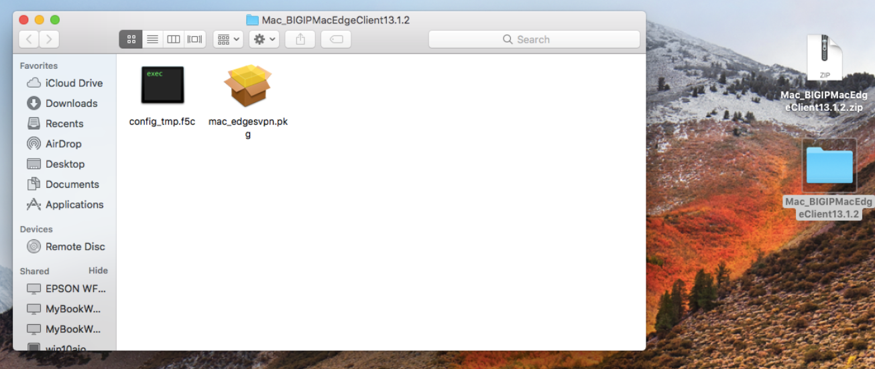
- This will run the installer.

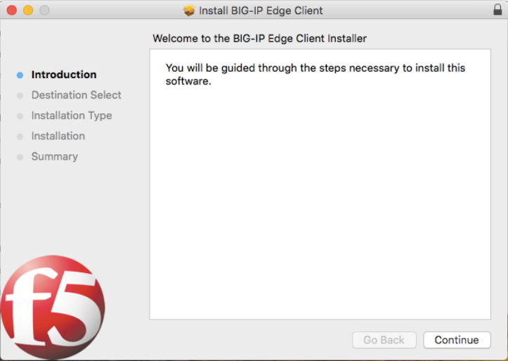

- Select the Destination drive.

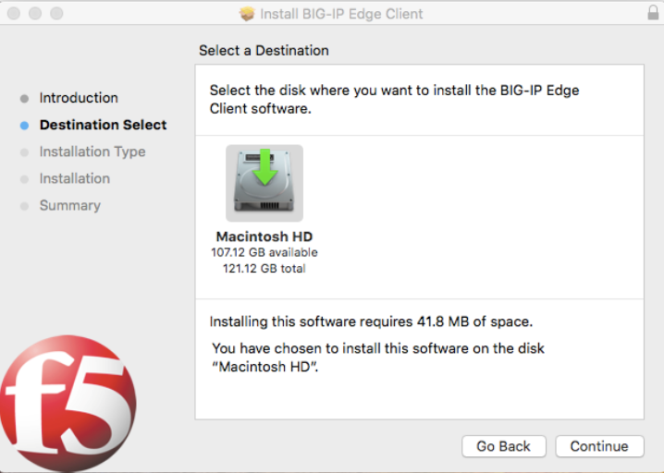
- Enter the admin password for the Mac.

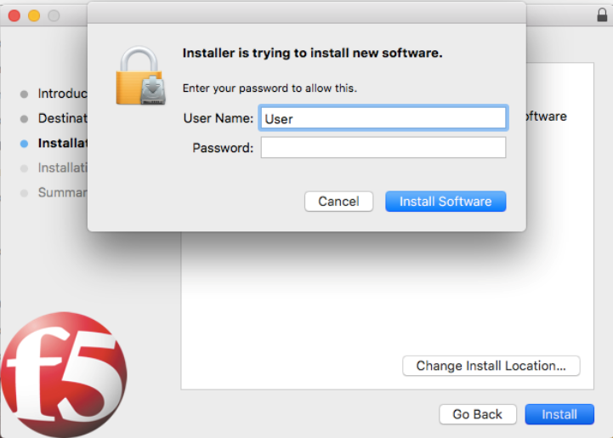

- Select the “Big-IP Edge Client” either by searching for it or by opening the Applications folder.

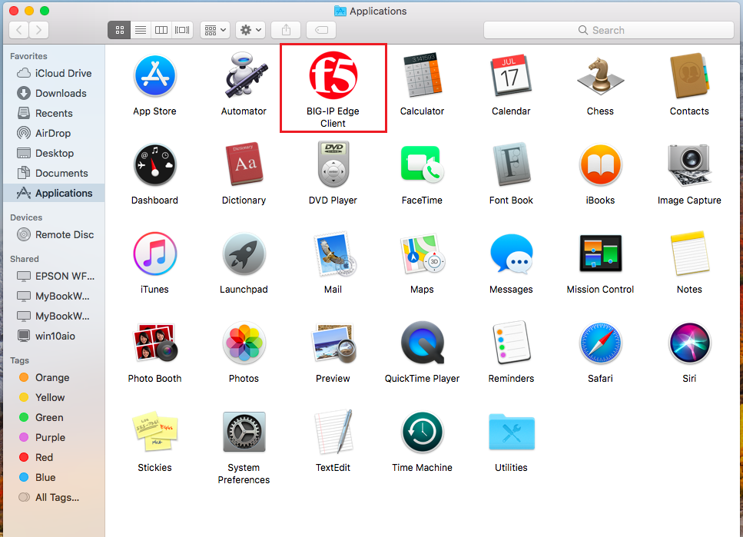

- Make sure “utvpn.uth.edu” is selected as the server from the drop down menu. If not, add it as a server. Then enter your credentials and click Connect or Logon.

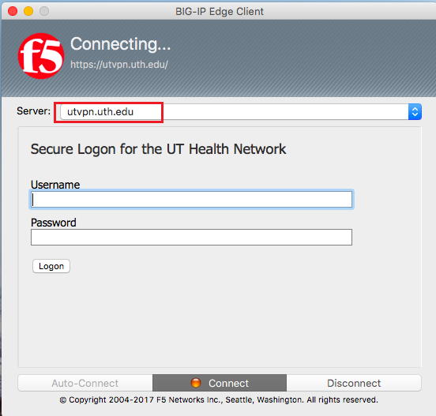

- The DUO Screen should come up to select your Two-factor authentication method.

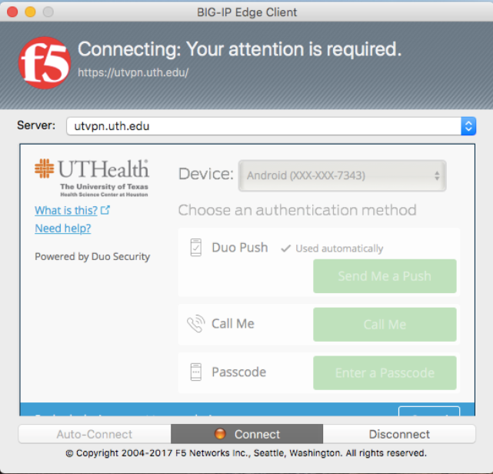
- After you select the second factor, the agent should connect.

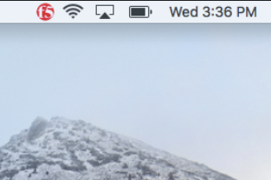

- You can click on the F5 icon and select additional details about the connection:

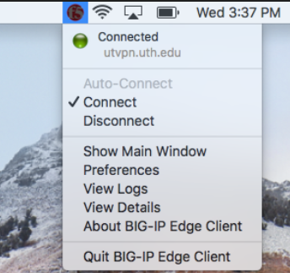

Chrome OS Client Installation

- Navigate to the Google Chrome Web Store.
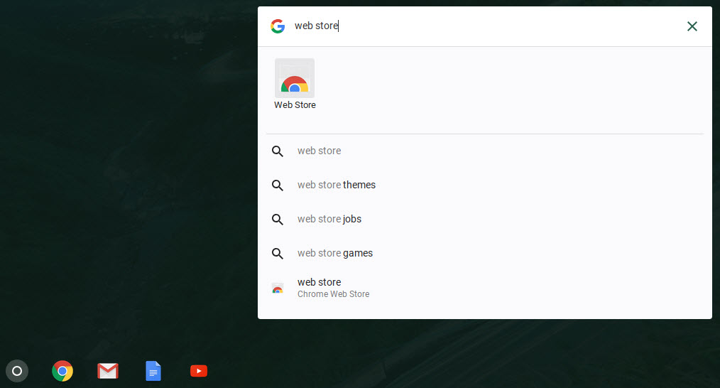

- Search for “F5 Access” and click the “ + Add to Chrome” button to download the F5 Access extension.
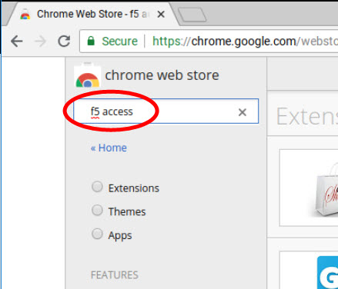
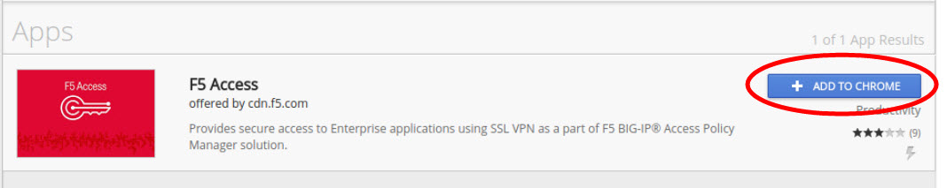

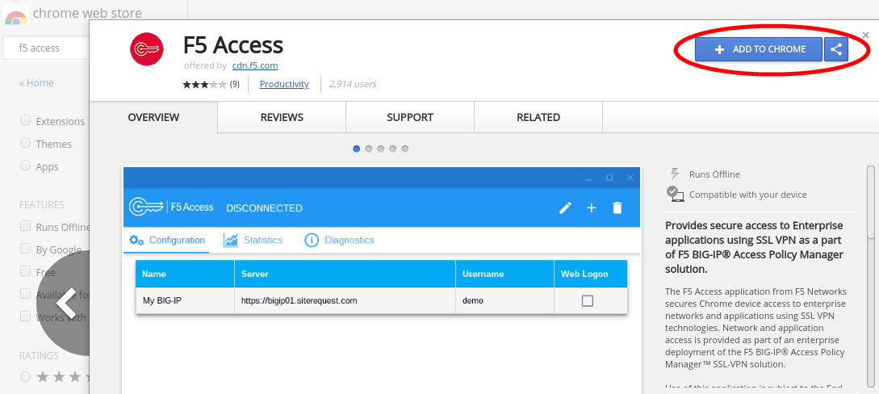

- Read the data privacy disclaimer and choose “Add app” to continue.
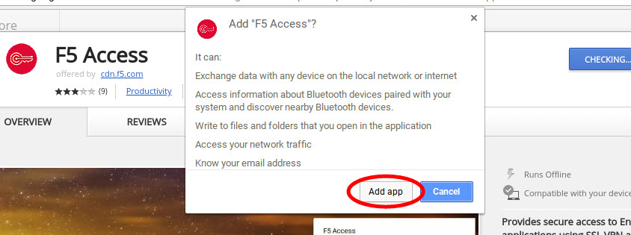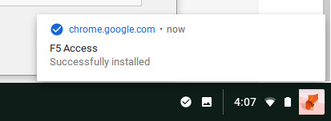
- Launch the application and accept the End User License Agreement (EULA).
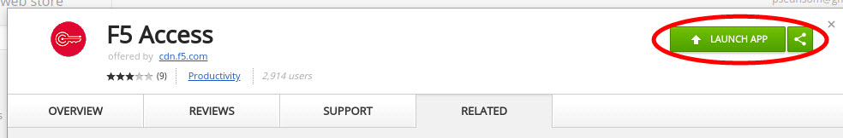

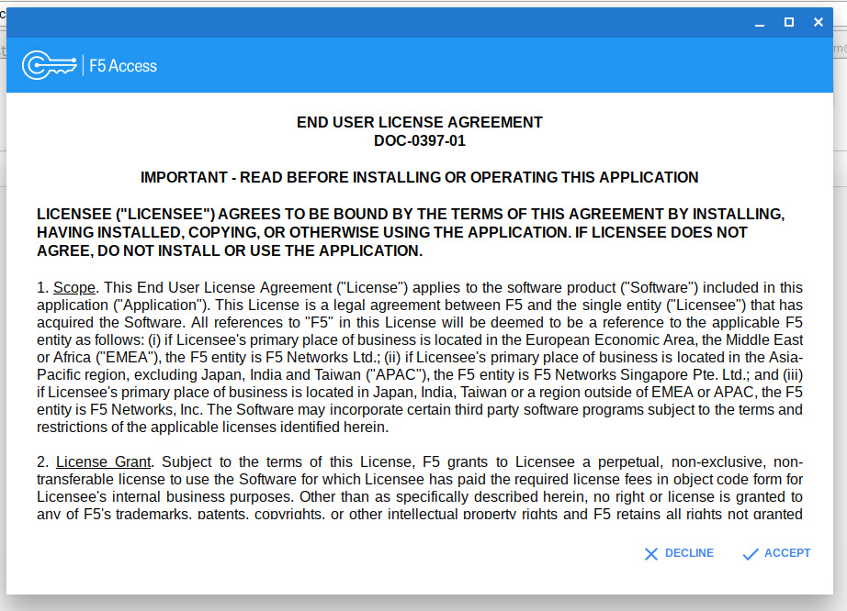

- Once the application has finished its initial setup, click the “ + “ icon to add a new VPN server configuration.

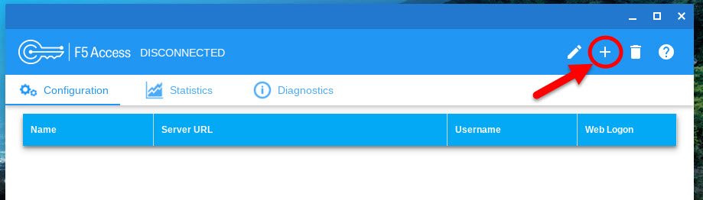
- Configure the new setup as shown below. Make sure to check the “Web Logon” option before saving the configuration and proceeding.

- Name: UTHealth VPN
- Server URL: https://utvpn.uth.edu
- Web Logon: selected
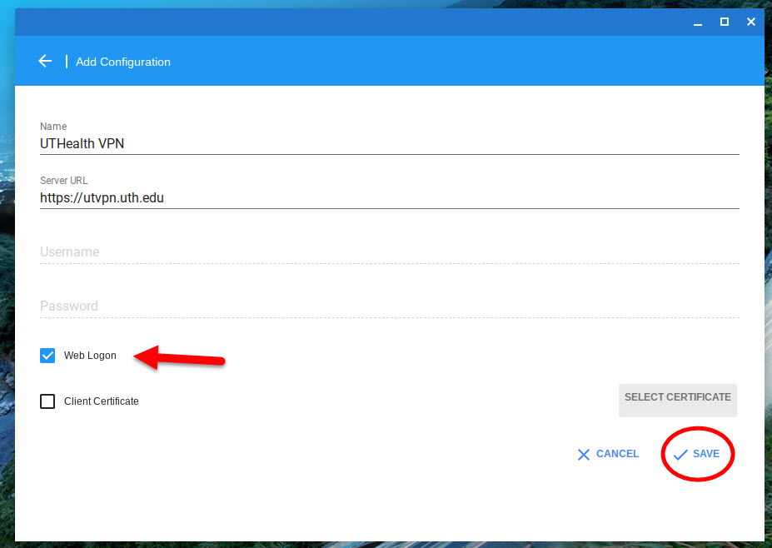

- Double-click the new VPN configuration created in the previous step and select the “UTHealth VPN” option on the bottom-right notification center.
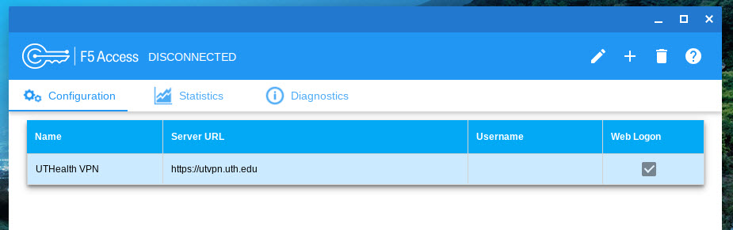
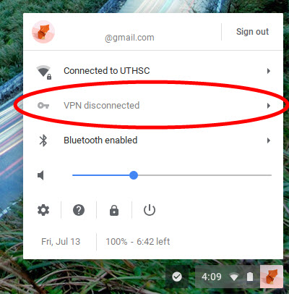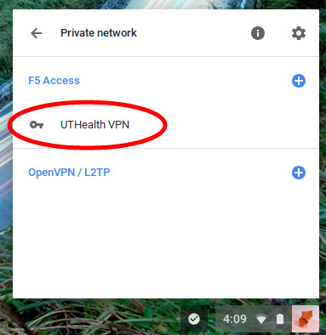

- Once the F5 VPN login screen appears, proceed with entering your UTHealth credentials and authenticating using your DUO two-factor device to connect to the VPN.

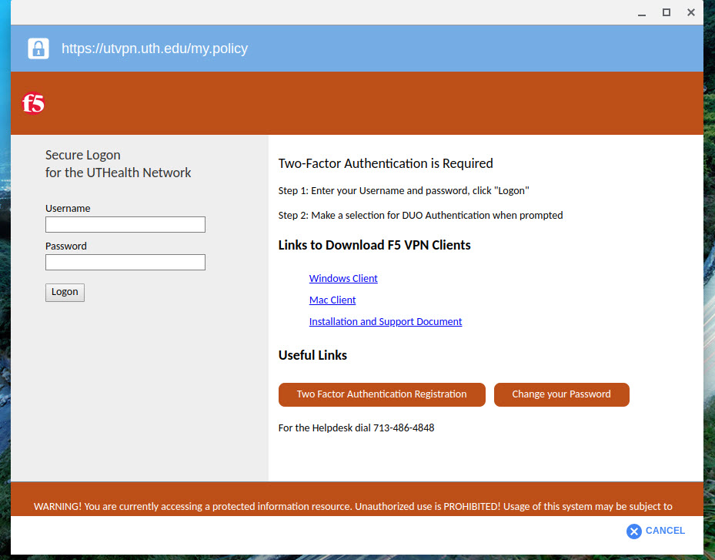

Android Mobile Client Installation

- Download the "F5 Access" app on your Android device.

- Configure a new connection. The name can be anything, but the server should point to "utvpn.uth.edu".

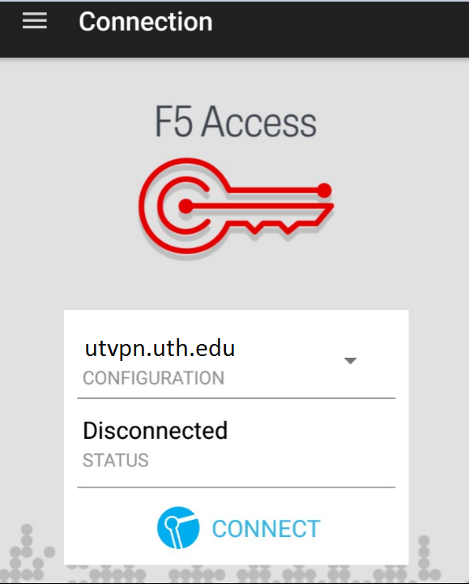
- After you create a new connection, select the pull down "Menu" on the top-left and choose "Configurations" as shown below:

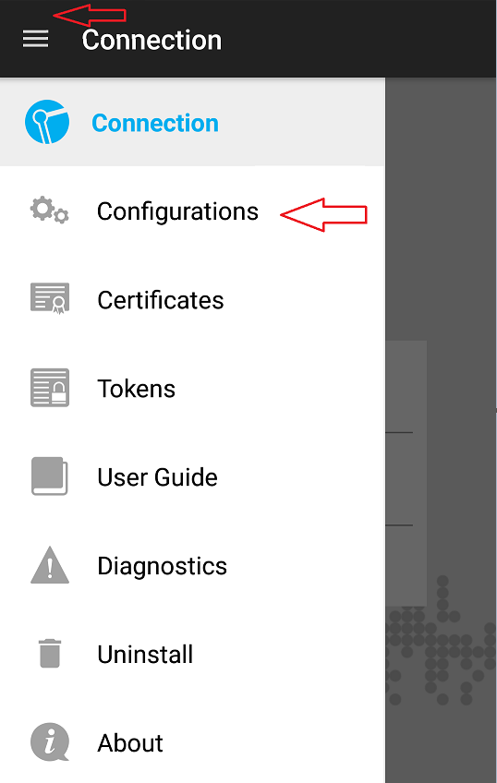
- Select the new connection that you created.

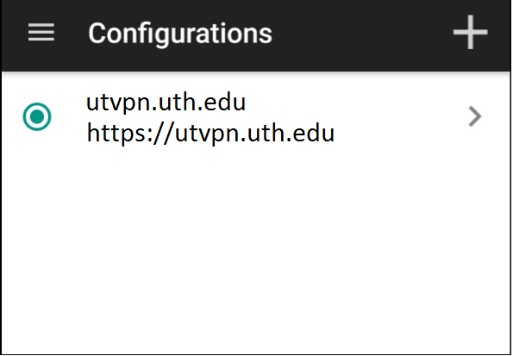

- Then finally add a checkmark to "Web Logon” and save your changes by pressing the checkmark on the top-right.

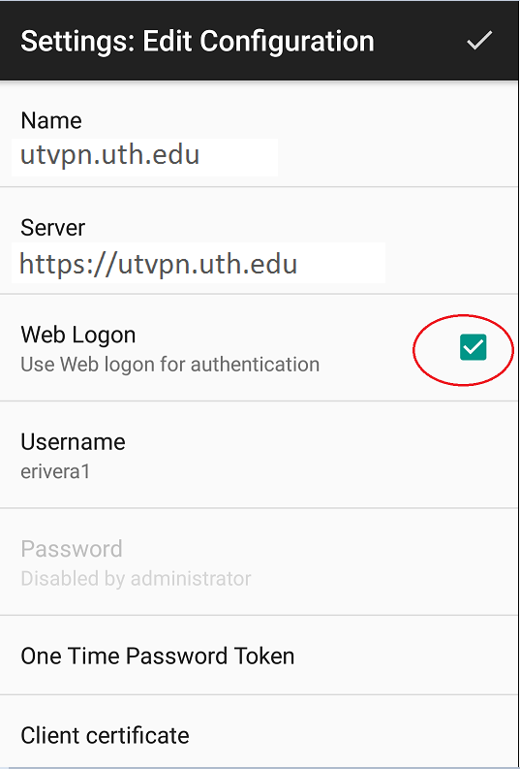

- You are all set.

iOS Mobile Client Installation

- In the iOS App Store, search for "F5" and download the "F5 Access for iOS" app.

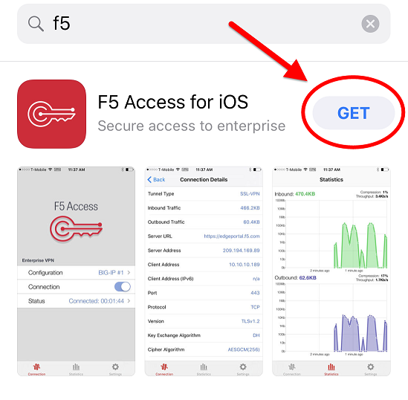
- Locate and open the "F5 Access" app icon on the home screen.

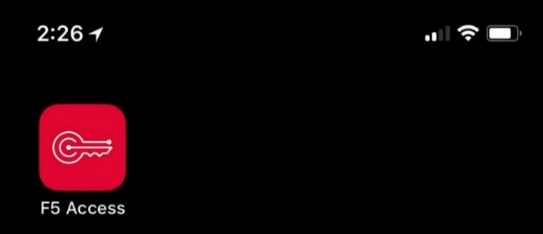

- If this is your first time opening the F5 Access app, you will have to agree to the terms found in the F5 Networks End User License Agreement (EULA) by selecting "Enable" to proceed.
The full EULA terms can be read online at https://cdn.f5.com/product/apm/apps/eula.html
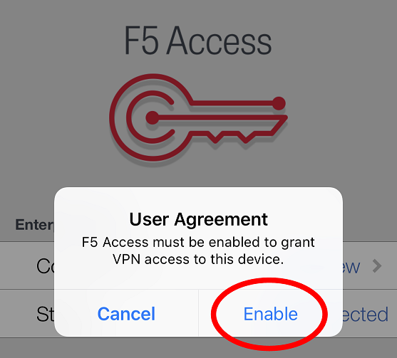
  - Press "Add New" to configure the UTHealth VPN connection.

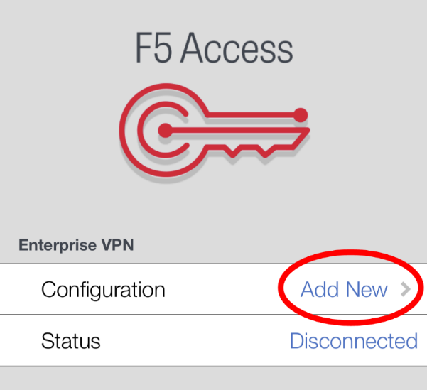

  - Enter the following information below into the Description and Server fields, and then press the slider to enable "Web Logon". (circled in red)
    - Description: UTHealth VPN
    - Server: utvpn.uth.edu

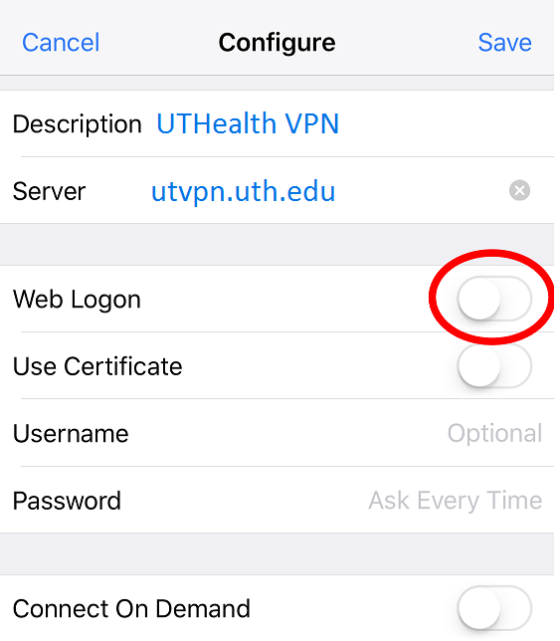

  - The finished settings should look like the configuration below.
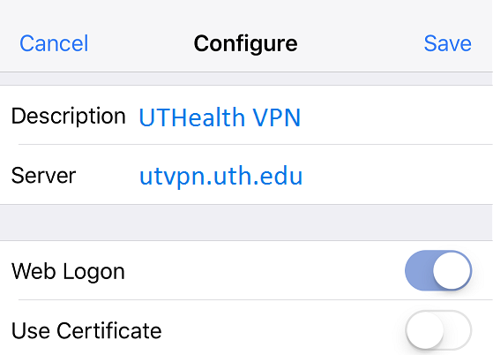
  - Back on the F5 App home screen, the new configuration title should be displayed. Press the slider next to Connection to the "On" position and start the VPN login process.

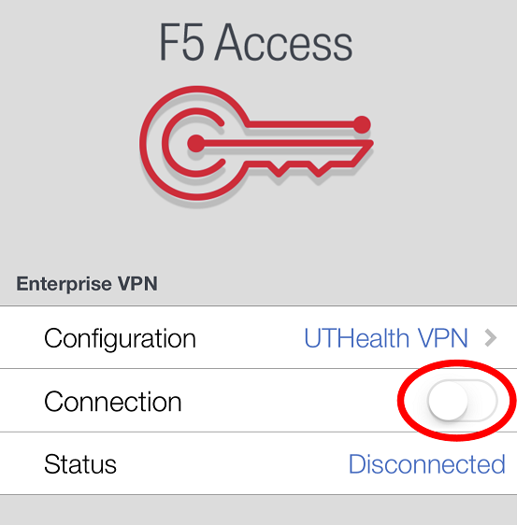

  - Enter your UTHealth login credentials to in the login screen shown below.

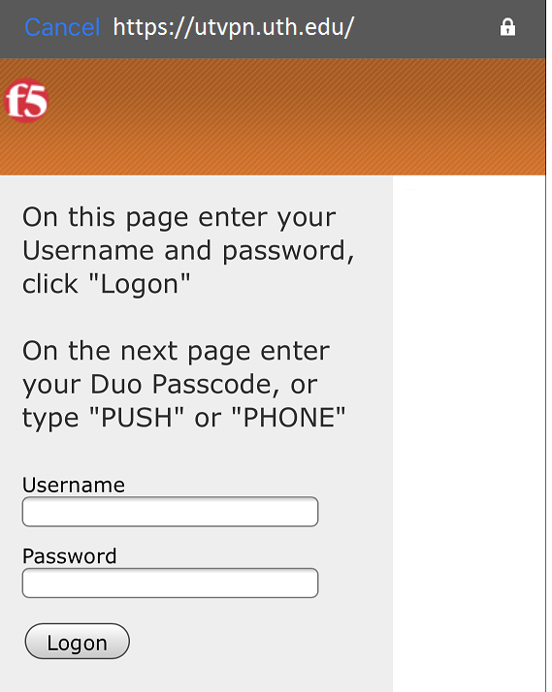

  - After a successful login, the DUO Two-factor authentication options will appear.
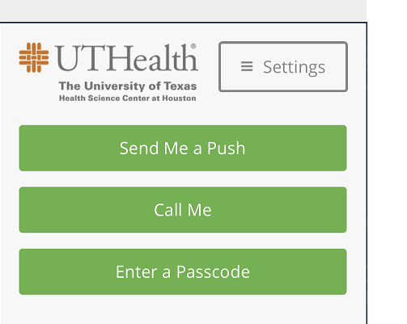
  - Once Two-factor authentication is successful, you'll be brought back to the F5 home screen that shows your connection slider is "On" and Status will be shown has "Connected".

  - You are now connected to UTHealth VPN.

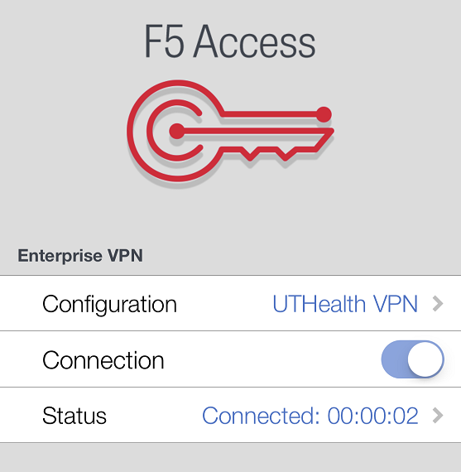

  - To disconnect from your UTHealth VPN connection, press the enable slider once again to the "Off" position. The Status will reflect that you've been disconnected.

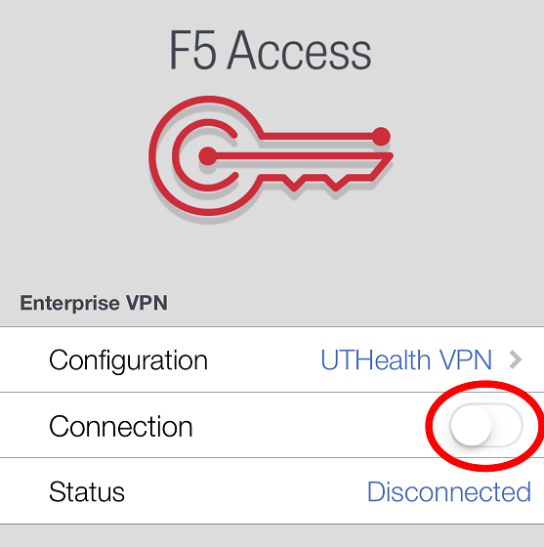

Linux Client Installation (Ubuntu)

- Go to: https://utvpn.uth.edu

- Login to the Web portal. It will detect that you are running Linux and will prompt you to download the version of the F5 Client that is right for you.

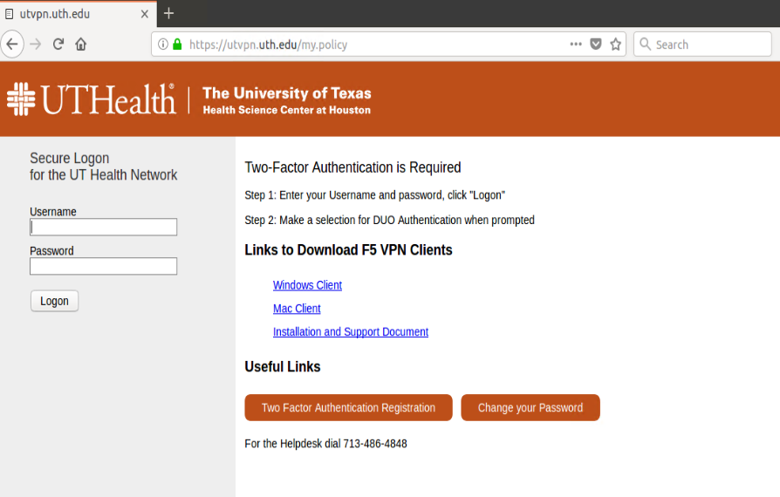

- Select the version of Linux that most closely matches your system. In the case below, the 64-bit version of F5 for Ubuntu Linux is selected.

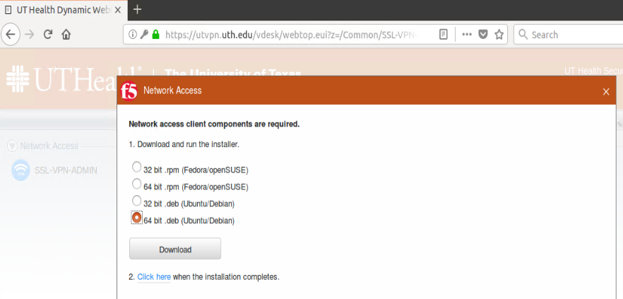
- After the F5 Agent is downloaded, double-click on "linux_f5vpn.x86_64.deb and you will get the option to install F5 Agent as shown below:

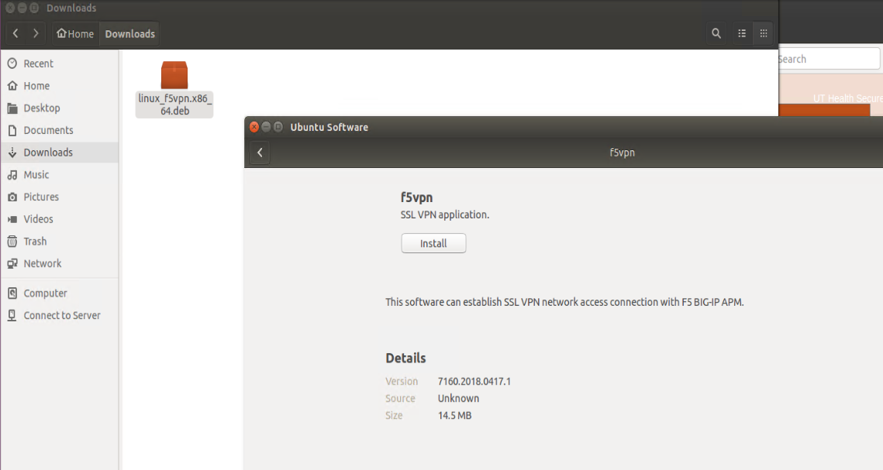

- Click “Install”, then you will be prompted for the local password.

- After the F5 client is installed, go back to your browser and select “Open link” as shown below:

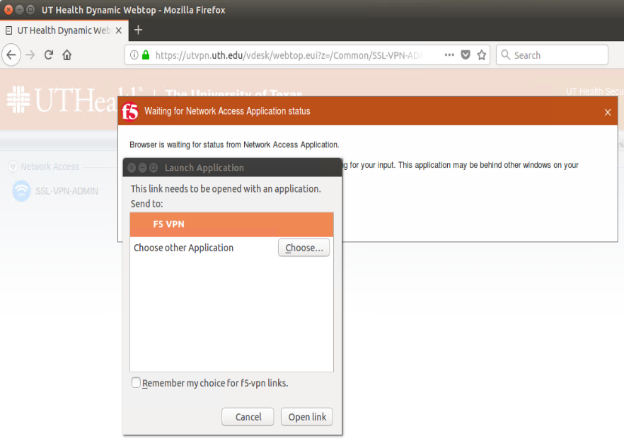
- Select "Always allow VPN Connections from this site" option.

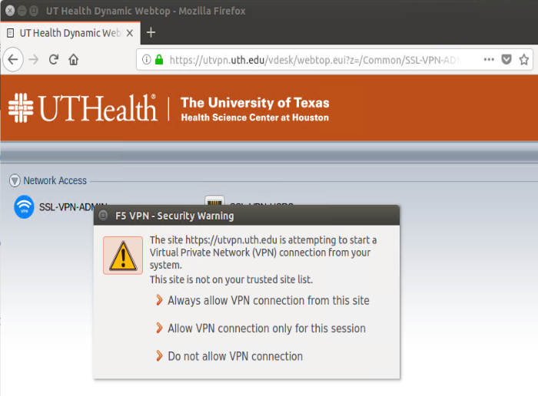
- Your system is all set.

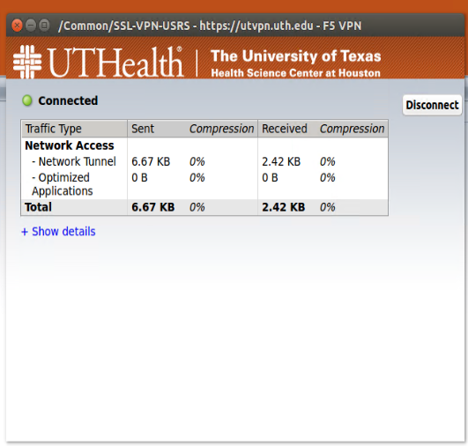

CONTACTS

Name of Technical Contact | Department | Telephone | E-mail
Helpdesk | Information Security | 713-486-34848 | helpdesk@uth.tmc.edu
IT Security Group Mailbox | Information Security |  | its@uth.tmc.edu

REVISION HISTORY

Preparer’s Name | Revision Date | Reason For Change | Version | Approver’s Name | Approval Date
Elias Rivera | 5/15/2018 | Initial document | 1.1
Elias Rivera | 6/26/2018 | Added Linux section | 1.2
Patrick Seunsom | 6/26/2018 | Minor updates | 1.3
Patrick Seunsom | 7/16/2018 | Minor updates | 1.4
Patrick Seunsom | 9/5/2018 | Added Chrome OS section | 1.5

